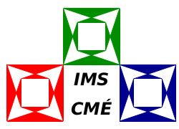

Kovalevskaya Grants / IMS Travel Grants
to support participation at the
International Congress of Mathematicians,
Saint Petersburg, July 6 – 14 2022.

Application form for a Kovalevskaya Grant / IMS Travel Grant
Please complete this application form and send to Kovalevskaya_Grant@irishmathsoc.org.
Please also attach an up-to-date curriculum vitae.
See https://icm2022.org/grants for further information.

Name:

Affiliation:

Gender:

Email address:

Current position:

Year in which PhD was awarded or expected year of award:

Have you registered for ICM22?: Yes / No
If ‘yes’, what is your ICM22 Number?

Write a short account of how attending ICM22 would be of benefit to you (max about 200 words):

Do you wish to apply for an IMS Travel Grant (max. €400) to cover travel to the ICM in Saint Petersburg? Yes / No

Do you have access to alternative travel support, e.g. research grant, departmental funds?
Yes / No.
If ‘yes’, please give details.

Please list the names and contact details of two referees that the IMS Committee may contact if necessary. If you are a PhD student, one should be your supervisor.

Checklist:
Completed application form
Curriculum vitae

The closing date is 30 September 2021; early application is encouraged.

